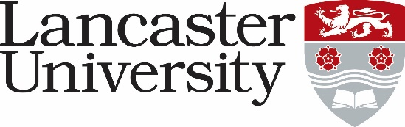

JOB DESCRIPTION
Careers and Employment Adviser, Careers
Vacancy Ref: Click here to enter text.

Job Title: Careers and Employment Adviser | Present Grade: Grade 6s
Department/College: Careers
Directly responsible to: Student Engagement and Quality Manager
Supervisory responsibility for: Careers Ambassadors
Other contacts

Internal: Faculty and Academic Departmental staff – academic and administrative; College Managers and other College staff; Staff within Student Based Services; Lancaster University Students’ Union; Current students

External: Employers and Recruiters, Professional Bodies, Other Higher Education Career Services, Prospective Students, Alumni and Graduates, third party suppliers of procured services ( e.g venues, design and print agencies, resource suppliers)

Major Duties:

- Lead the strategic development, delivery and assessment of the Lancaster Award, the University’s flagship employability initiative, supporting over 500 student participants each year and ensuring a high quality, transformative experience.
- Champion career development as a core element of the Lancaster student journey by providing informed, tailored one-to-one advice and guidance to students across all faculties and levels of study.
- Manage and deliver fast paced Careers drop-in services, offering responsive, accurate and supportive employability information to meet the immediate needs of students.
- Collaborate with colleagues to evaluate current employability provision, contributing insight and recommendations that shape future service innovations and enhance student experience.
- Design and deliver engaging presentations, workshops and skills sessions as part of the University’s Careers and Employability portfolio, ensuring content is research informed, accessible and impactful.
- Develop high quality careers resources for print and digital formats, including leaflets, guides and web content, ensuring alignment with Lancaster University’s communication standards and brand guidelines.
- Analyse and interpret data relating to career readiness, service engagement and Graduate Outcomes, using insights to inform planning, continuous improvement and evidence-based decision making within the service.
- Build and maintain effective relationships with graduate employers, professional bodies, alumni and sector partners, promoting Lancaster University, enhancing employer engagement, and sourcing meaningful opportunities for students and graduates.
- Utilise the CareersConnect enquiry and case management system to log, track and manage student interactions, ensuring accurate records and a seamless student experience.
- Contribute to student recruitment, engagement and retention activities, including Open Days, Offer Holder Events and cross University networking, working collaboratively with colleagues to showcase Lancaster’s distinctive student experience.

